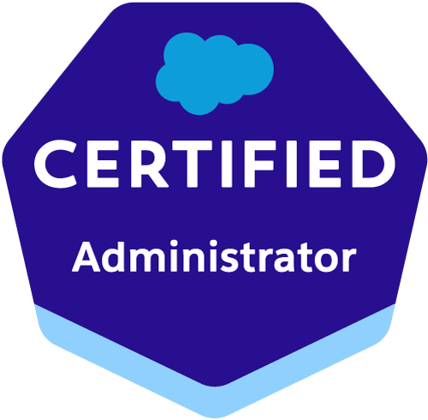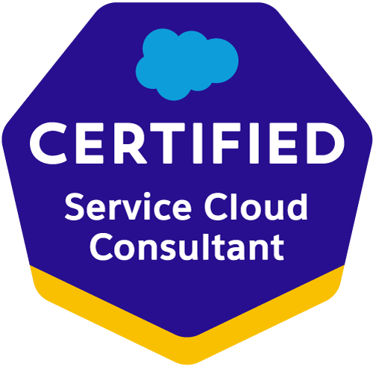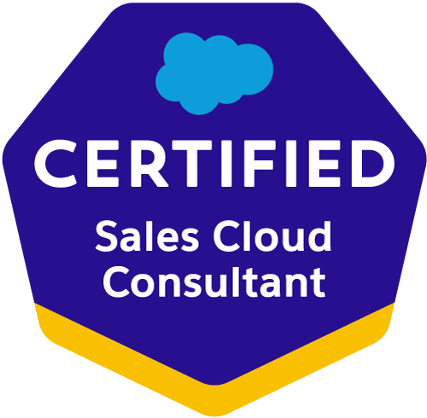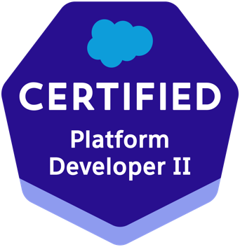

Akhiel Pasha Mohammad
Email: akhielmohammad@gmail.com
Phone: +1(551)220-7631
https://www.salesforce.com/trailblazer/amohammad130
__________________________________________________________________________________________________________________

Professional Summary:
Salesforce developer with Around 5+ years of experience in building, testing, iterating and deploying changes supporting technical maintenance, ongoing enhancements to existing features, and new functionality. A proven problem solver with abilities in troubleshooting escalated support issues by performing analysis on the root cause and implementing short and long-term solutions.

_________________________________________________________________________________________________________

Education:

Master of Science in Information System Technologies
Wilmington University, Delaware, USA Aug 2021 – Dec 2022

Bachelor of Technology in Electronics and Instrumentation Engineering
Kakatiya Institute of Technology & Sciences, India Aug 2015 - May 2019

______________________________________________________________________________________________________________________________

Technical Skills:

Salesforce Technologies | SalesForce.com, Force.com, Sales Cloud, Service Cloud, LWC, Lighting components, CPQ, Apttus CPQ, Apex Language, Apex Classes/Controllers, Apex Triggers, SOQL, SOSL, Visual Force Pages/ Component, s-Control, Apex Web Services, Partner WSDL & Enterprise WSDL, Workflow and Approvals, Dashboard, Analytic Snapshots.
Salesforce Tools | Force.com IDE (Eclipse), AJAX Tool Kit, Force.com API tools (Data Loader), Force.com Explorer, Force.com Platform
ETL Tools | Data Loader, Salesforce-to-Salesforce, Apex- Explorer, Informatica.
Languages | Apex, C/C++, Java, HTML, XML, CSS.

Professional Experience:

Client: PSEG Jan 2023 – present
Role: Salesforce Admin/Developer
Location: Edison, NJ

Responsibilities:

- Worked extensively on Salesforce object and field management, efficiently customizing both standard and custom objects to meet diverse business needs.
- Demonstrated expertise in defining relationships between objects using lookup and master-detail relationships, ensuring optimal data structure alignment.
- Utilized a strong understanding of various field types, such as text, picklist, date, and formula fields, to create and modify fields tailored to specific data requirements.
- Successfully designed relational data models to optimize Salesforce functionality, achieving project objectives and enhancing overall system efficiency.
- Collaborated closely with stakeholders throughout projects, gathering requirements and defining object relationships to ensure alignment with business goals.
- Ensured data integrity through effective object and field configurations, maintaining high standards of accuracy and reliability.
- Leveraged FSL reports to track technician productivity, job completion rates, and SLAs, providing valuable insights for performance evaluation and improvement.
- Proficiently created dynamic FSL dashboards to offer real-time visibility into field service operations, facilitating informed decision-making processes.
- Demonstrated expertise in customizing FSL reports to optimize service processes, fostering collaboration and enhancing project outcomes.
- Led the end-to-end implementation of FSL, tailoring workflows to align with specific business requirements and improve operational efficiency.
- Configured and customized Salesforce Service Console using Lightning App Builder and Console Builder.
- Excellent knowledge in creating Salesforce.com Page Layouts, Record Types, Validation Rules, Workflows, Email templates, Approval Processes.
- Implemented custom console components, page layouts, and console apps to optimize user interface and streamline case management processes.
- Developed Lightning components, Visualforce pages, and Apex controllers to extend functionality within the Service Console.
- Implemented Data Integration using SOAP, REST API and outbound Messaging to establish the communication between SFDC and External systems.
- Demonstrated expertise in Salesforce development, specializing in Apex and Lightning Web Components, to craft sophisticated solutions that align with organizational objectives and drive business growth.
- Proficiently integrated JavaScript, REST/JSON, and XML technologies to orchestrate seamless interactions between Salesforce and external systems, amplifying data accessibility and system functionality.
- Implemented robust process automation methodologies utilizing Salesforce tools such as Flow and Batch/Async Apex, optimizing workflows and enhancing operational efficiency.
- Leveraged comprehensive knowledge of core Salesforce configuration principles, including Permissions, objects, fields, and UI customization, to tailor solutions tailored to the specific requirements of Salesforce Sales/Service and Financial Services Cloud deployments.
- Hands on experience in implementing security and sharing rules at object, field, and record level for different users at different levels of organization. Also created various profiles and configured the permissions based on the organizational hierarchy.
- Experience in SFDC development using Apex classes and Triggers, Visual Force, Force.com IDE, SOQL, SOSL
- Good experience in working on Eclipse IDE with Force.com Plug-in for writing business logic in Apex programming language.
- ﻿﻿Experienced in use of Standard and Custom controllers of Visualforce in development of custom Salesforce pages as required by business requirements.
- Applied agile development methodologies and Test-Driven Development (TDD) practices to deliver high-quality solutions within iterative development cycles, ensuring alignment with project timelines and quality standards.
- Effectively collaborated with cross-functional teams and business stakeholders to gather requirements, provide technical guidance, and drive project success through effective communication and collaboration.
- Utilized advanced testing tools such as SOAPUI, Postman, and Selenium to conduct comprehensive testing and ensure the reliability and performance of Salesforce applications.
- Implemented monitoring and logging techniques to proactively identify and address issues, maintaining system stability and performance at all times.
- Developed comprehensive test cases using Salesforce's Apex testing framework to ensure the reliability and functionality of custom Apex classes, triggers, and Lightning components.
- Achieved consistent code coverage above 90% for Salesforce Apex classes and triggers through meticulous test case design and execution.
- Implemented unit tests, integration tests, and end-to-end tests to validate business logic, data manipulation, and user interactions within Salesforce applications.
- Conducted code reviews and provided feedback to peers to ensure adherence to coding standards, test coverage requirements, and best practices for Salesforce development.
- Analyzed code coverage reports and identified areas of low coverage or untested code to prioritize test case development and improve overall code quality.

Wilmington University Jan2022 – Dec 2022
Role: Salesforce Admin/Developer

- Provided administrative support and assistance to university faculty and staff.
- Utilized Salesforce to manage student records, inquiries, and communications.
- Assisted in configuring Salesforce to meet specific departmental needs and workflows.
- Collaborated with team members to streamline processes and improve efficiency.
- Trained faculty and staff on Salesforce usage and best practices.
- Generated reports and dashboards to track student data and program metrics.
- Participated in ongoing Salesforce training and professional development opportunities.
- Provided administrative support and assistance to university faculty and staff.

Client: Slack System, Hyderabad June 2019 – August 2021
Role: Salesforce Admin/Developer

Roles and Responsibilities:
- Involved in Creating Custom Objects, Fields, Relationships and Tabs.
- Preliminary analysis on tickets raised by Country Admin.
- Resolve tickets as per country Salesforce admin and update them in Remedy Tool.
- Maintain and support custom objects, formulas, layouts, validation rules, workﬂows, process builder, approvals, and assignment rules.
- Expert in resolving the tickets as per SLA.
- Experience using Salesforce data tools (Data Loader, Import Wizard) for managing mass data updates.
- Designing of Reports and Dashboards according to the requirement
- Worked on salesforce security model.
- Having experience on conﬁgure and manage Sales and Service Cloud applications.
- Experience using salesforce inspector and workbench.
- Experience in writing SOQL queries
- Good knowledge on Apex Classes, Triggers, and visual force Pages to troubleshoot the issues through debug log.
- Preliminary analysis on tickets raised by Country Admin.
- Resolve tickets as per country Salesforce admin and update them in Remedy Tool.
- Working with management and end-users to create and manage workﬂow rules, data validation.
- Expert in resolving the tickets as per SLA.
- Experience using Salesforce data tools (Data Loader, Import Wizard) for managing mass data updates.
- Worked on salesforce security model.
- Having experience on conﬁgure and manage Sales and Service Cloud applications.
- Experience using salesforce inspector and workbench.
- Experience in writing SOQL queries.
- Good knowledge on Apex Classes, Triggers and visual force Pages to troubleshoot the issues through debug log.
- Used postman to update or verify API Calls.

